IBM ICP – international business Machine – cloud private

Install the

<https://github.com/docker/machine/issues/4271>

What is Kubernetes

international business

# Docker installation steps

1. Docker icon present in the rightside menu list



1. Open power shell

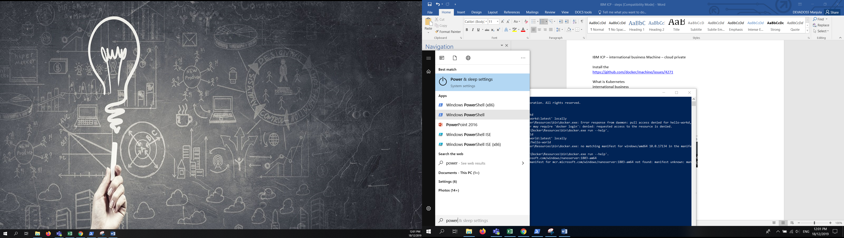



# Unable to find image

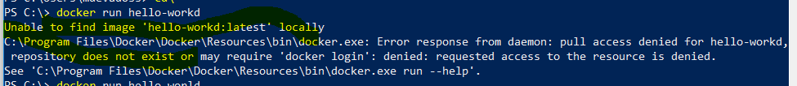

Right click from docker icon and choose setting

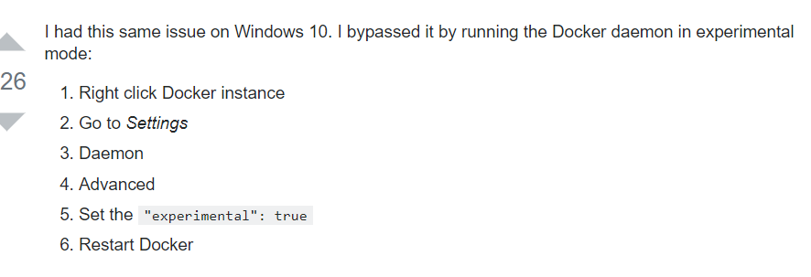

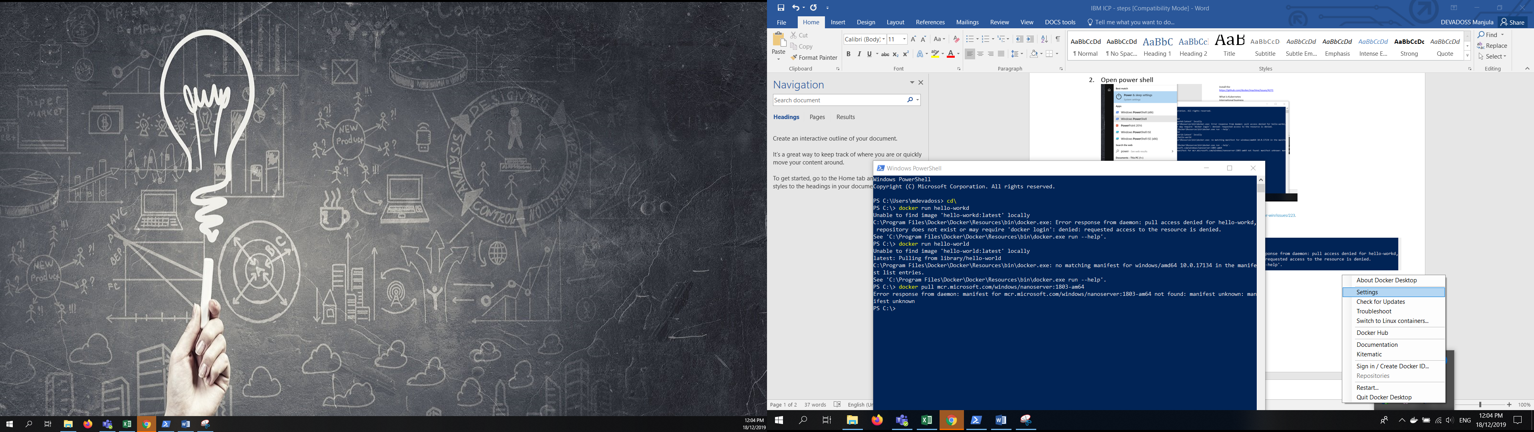

1. Look for Daemon - change “Basic ” to “Advance”

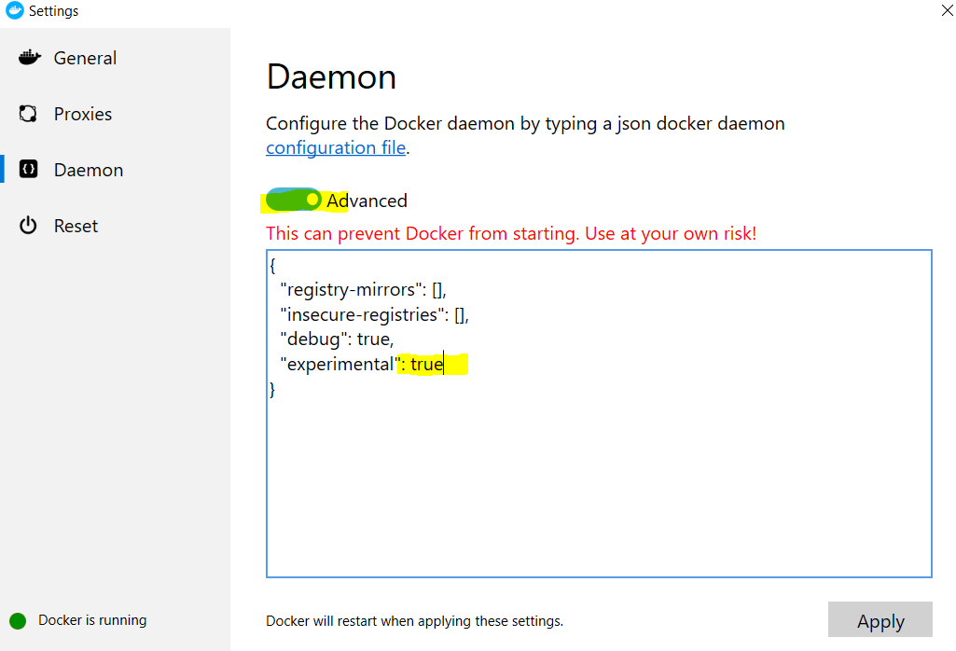

# Switch Linux container to windows container

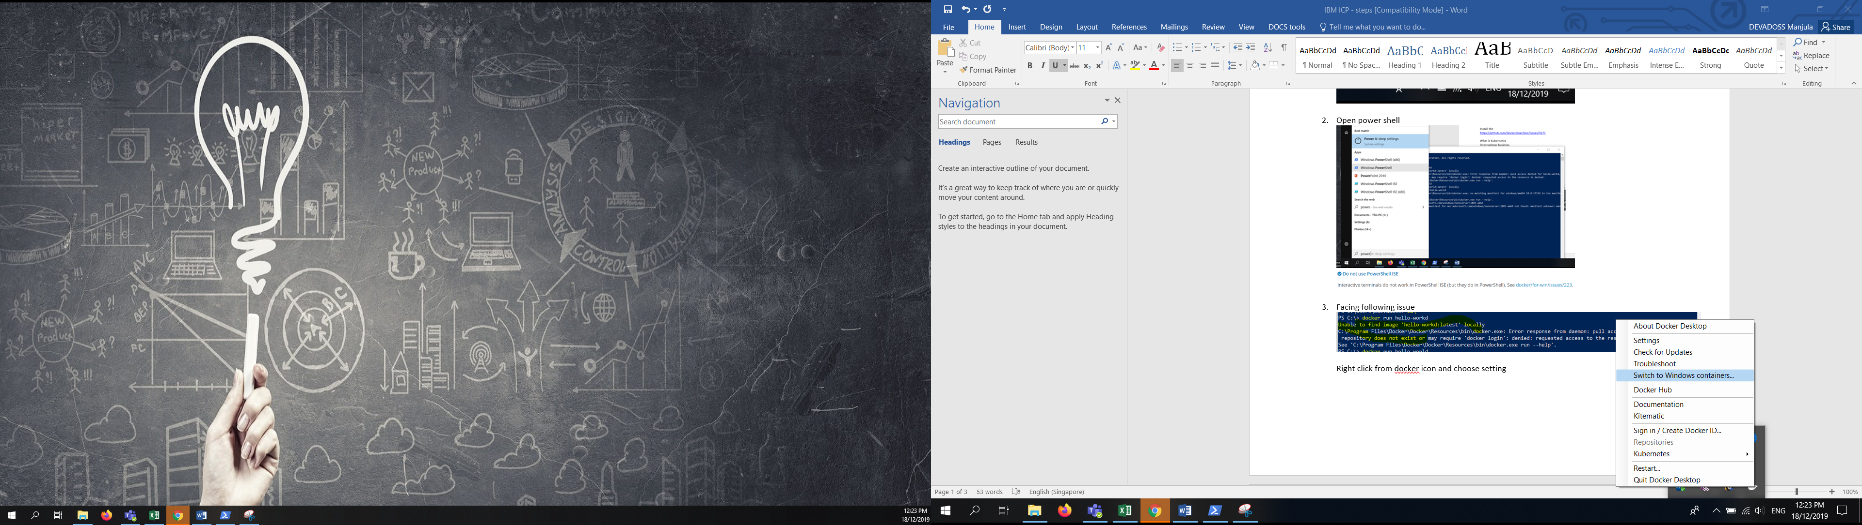 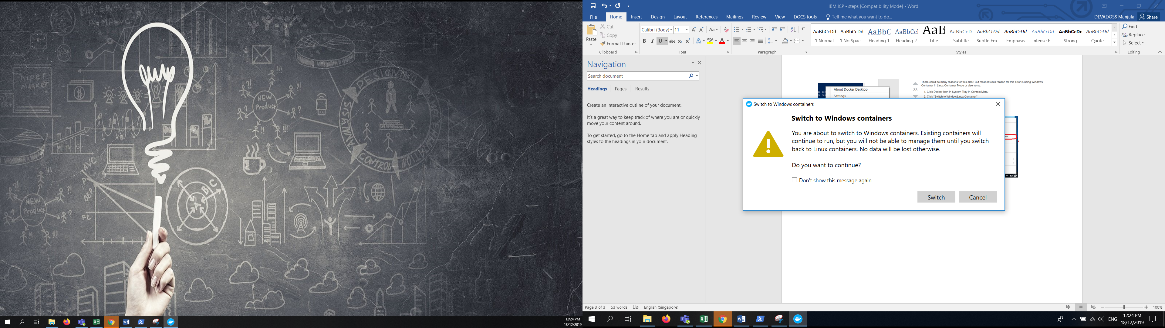

**Switch to windows containers – (Press Switch)**

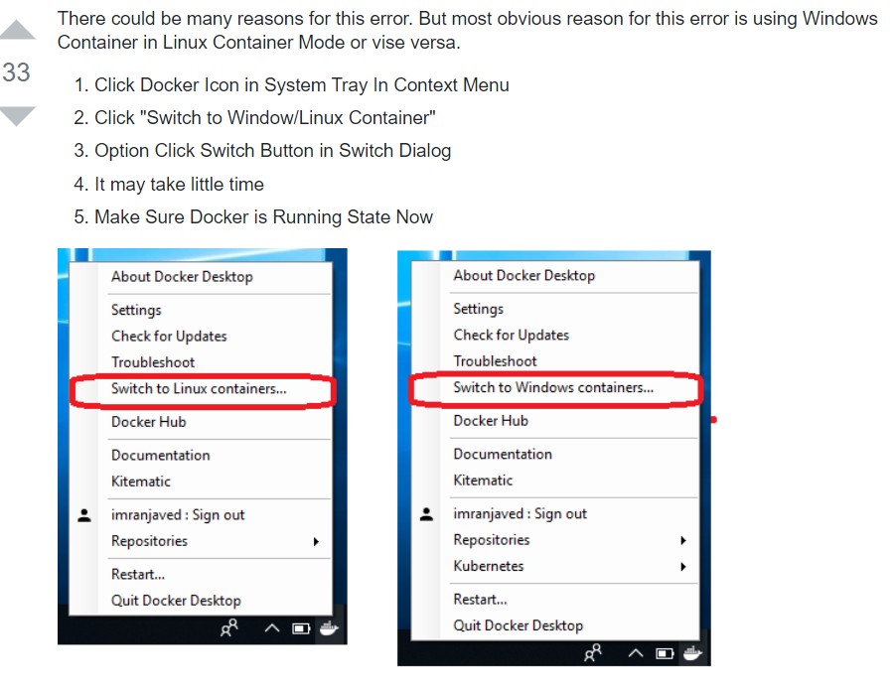

# ICP Client Installation

**Goto** command prompt **to login icp – only for Frist time**

ICP Login: https://10.180.11.140:8443

itpt2user

P@55w0rd

**Goto** Browser **login icp**

ICP Login: https://10.180.11.140:8443

itpt2user

P@55w0rd

**1. Install the following CLI**

1. IBM Cloud Private CLI

1. Copy the command and run
2. It will Create the client file

2. Kubernetes CLI

1. Copy the command and run
2. It will Create the client file

3. Helm CLI

1. Copy the command and run
2. It will Create the client file

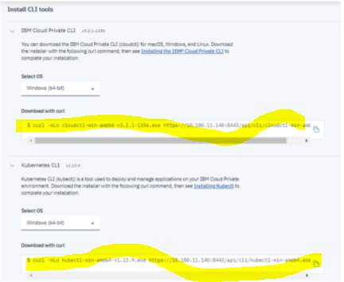

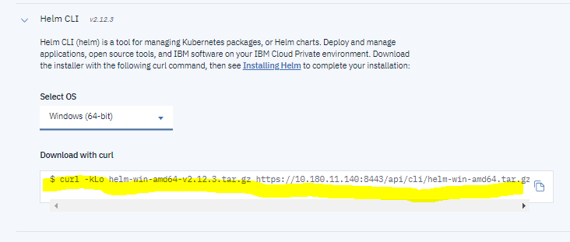

The following files you get – name slightly different – rename the files in the corresponding name.

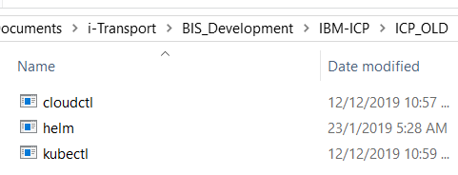

1. **Set environment path**
2. **Add ip to daemon – right click setting from the Docker**

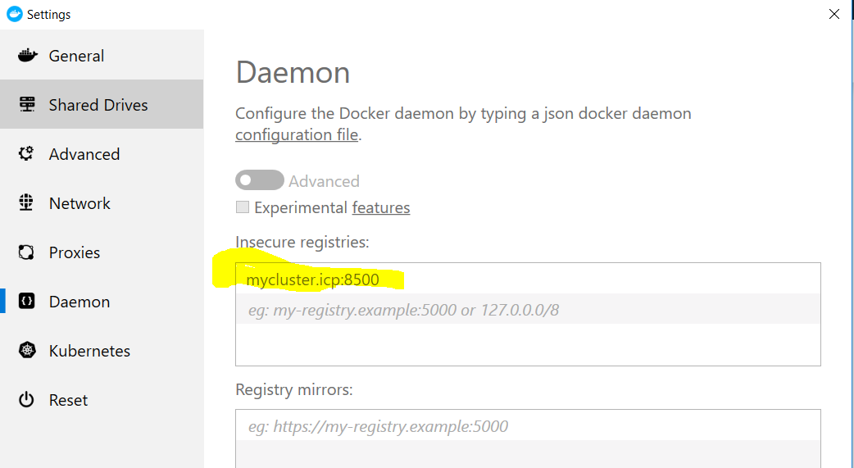

**Add** mycluser.cip:8500

Open – **hosts file**

**Add -** 10.180.11.140 mycluser.cip

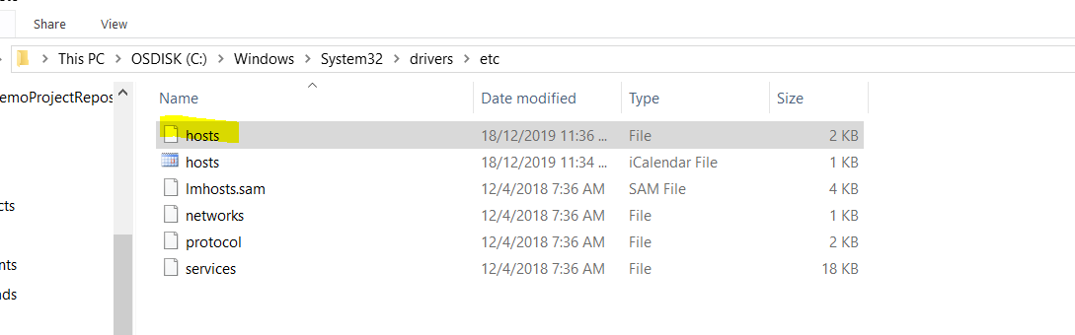

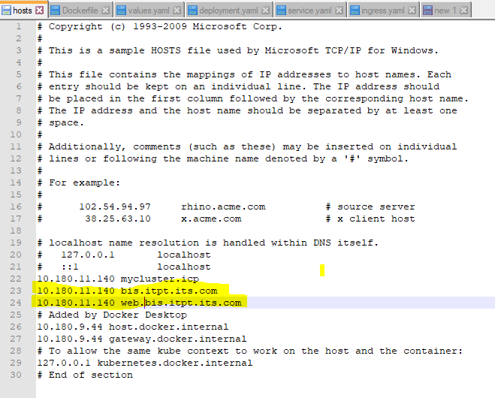

1. Goto command prompt

Cmd > docker login mycluster.icp:8500

Username >

Password >

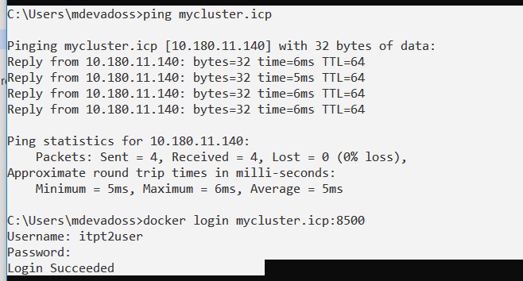

1. To view all image -- docker image ls

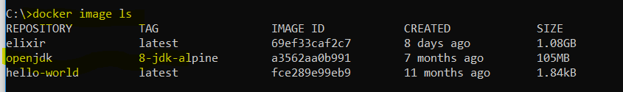

1. Build the Dockerfile to get image
   1. Go to the docker file location then run the blow command

|  |
| --- |
| docker build -t imagename:tagname .  docker build -t mycluster.icp:8500/default/image2:19.2 . |

1. Push image file to server repository

|  |
| --- |
| docker push mycluster.icp:8500/default/image2:19.2  image2 – repository   * 1. – image |

Check docker image is working properly **use run command**

|  |
| --- |
| docker run mycluster.icp:8500/default/image2:19.2 |

Press Ctrl+C to stop the execution

1. **Login to cloudclt**

|  |
| --- |
| **Choose Configure Client**  **Copy the above command and run in command prompt.**  **Output :** |

|  |
| --- |
| cloudctl login -a https://10.180.11.140:8443 -u itpt2user -p P@55w0rd -n default  **or**  cloudctl login -a https://10.180.11.140:8443 -u itpt2user -p P@55w0rd -n services  check its for default or service use service on |

1. intilization to helm

|  |
| --- |
| helm init –c  **Output :** |

1. To create helm chart

This will create one folder with service.yml file, deployment.yml, values.yml

|  |
| --- |
| **helm create chartname** |

Changes the above file with port/ chart / image name

Values.yaml, service, yaml, deployment.yaml, ingress.yaml

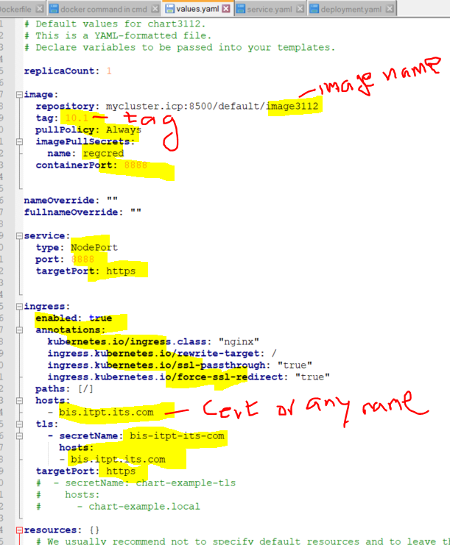

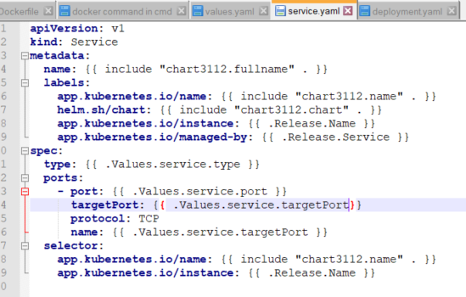

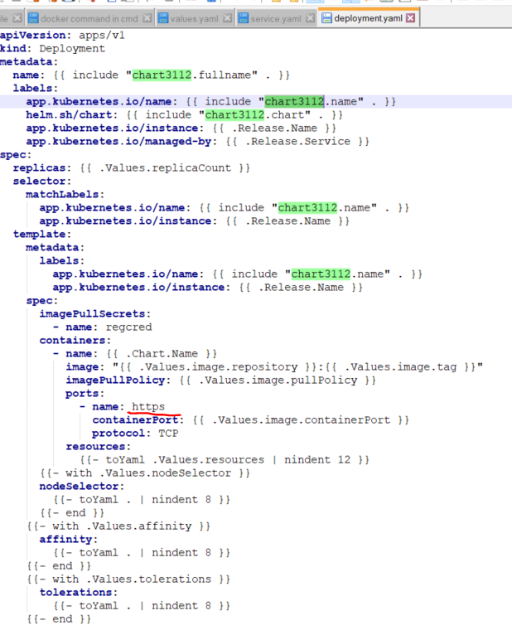

1. Install and delete the helm chart

|  |
| --- |
| **helm install --name=bisdiploy ./chart1 --tls**  **bisdiploy – any name for deployment**  **chart1 - is your chart name**  **helm del --purge bisdiploy --tls** |

1. Add ip to the host file

|  |
| --- |
|  |

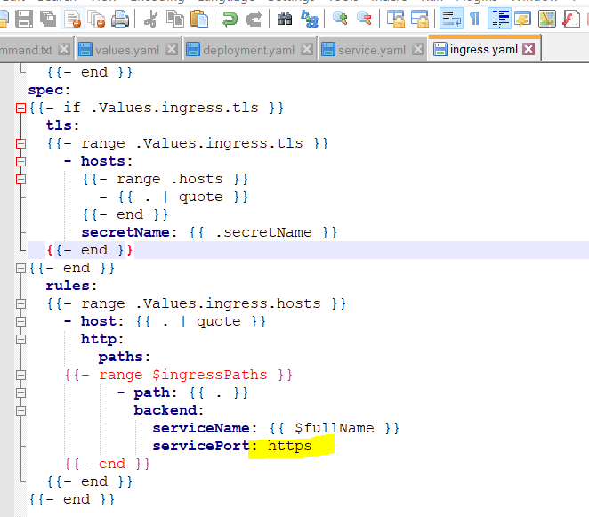

## Kubernatic commands

14. To see the log – kubectl / logs

|  |
| --- |
| --- to see log files  **kubectl get pods**  -- to open a log file  **kubectl logs bisdiploy1-chart1-5bb989695d-bz76p**   * to all pods in different name space   **kubectl get pods --all-namespaces** |

15. Describe service and deployment

|  |
| --- |
| **kubectl describe services**  **kubectl describe deployments**  **kubectl get ingress**  **kubectl describe pods bisdiploy-chart1-647dd46f6b-wzv8g** |

|  |
| --- |
| **kubectl config use-context mycluster-context**  **kubectl config set-context mycluster-context --user=itpt2user --namespace=services**  **kubectl config set-cluster mycluster --server=https://10.180.11.140:8001 --insecure-skip-tls-verify=true** |

16. Hit the URL

http://ip:port/bis/ext/swagger-ui.html

<https://bis.itpt.its.com/swagger-ui.html>

# FrontEnd & BackEnd – ICP IBM file location

**cmd prompt - Backend**

1) docker build -t mycluster.icp:8500/default/bisimage:0.1 .

1.1) (Delete Image): docker rmi -f IMAGEID:<tag>

2) docker login mycluster.icp:8500

3) docker push mycluster.icp:8500/default/bisimage:0.1

4) copy "ICP Cloud configure client" and paste in prompt

5) cloudctl login -a https://10.180.11.140:8443 -u itpt2user -p P@55w0rd -n services

6) helm init –c

7) helm create bischart

8) Modify Values.yaml, service, yaml, deployment.yaml, ingress.yaml

9) helm install --name=bis-api ./bis-api-chart --tls

9.1) (Delete Deploy): helm del --purge bis-api --tls

10) kubectl get pods

11) kubectl logs

**FrontEnd**

Note : Dist folder and paste into Dockerfile location

1) docker build -t mycluster.icp:8500/default/biswebimage:0.1 .

2) docker login mycluster.icp:8500

3) docker push mycluster.icp:8500/default/biswebimage:0.1

4) copy configure client and paste in prompt

5) cloudctl login -a https://10.180.11.140:8443 -u itpt2user -p P@55w0rd -n services

6) helm init –c

7) helm create biswebchart

8) Modify Values.yaml, service, yaml, deployment.yaml, ingress.yaml

9) helm install --name=biswebdeploy ./biswebchart --tls

10) (Error) if you get this error : "ImagePullBackOff"

kubectl create secret generic regcred --from-file=.dockerconfigjson=config.json --type=kubernetes.io/dockerconfigjson

**Docker file creation**

https://medium.com/@wkrzywiec/build-and-run-angular-application-in-a-docker-container-b65dbbc50be8

**Docker other commands-**

delete unused images

1.1) Removing Docker Image : docker rmi IMAGEID

(Error) Error response from daemon: conflict: unable to delete then use -f command below

1.2) Removing Docker Image : docker rmi -f IMAGEID

(Error) Error: Conflict

1.2) Removing Docker Image : docker rmi -f IMAGEID:<tag>

2) Removing Docker Container : docker system prune

2) List Docker image : docker image ls

**Other way to access**

Install nginx – nginx/windows-1.16.1

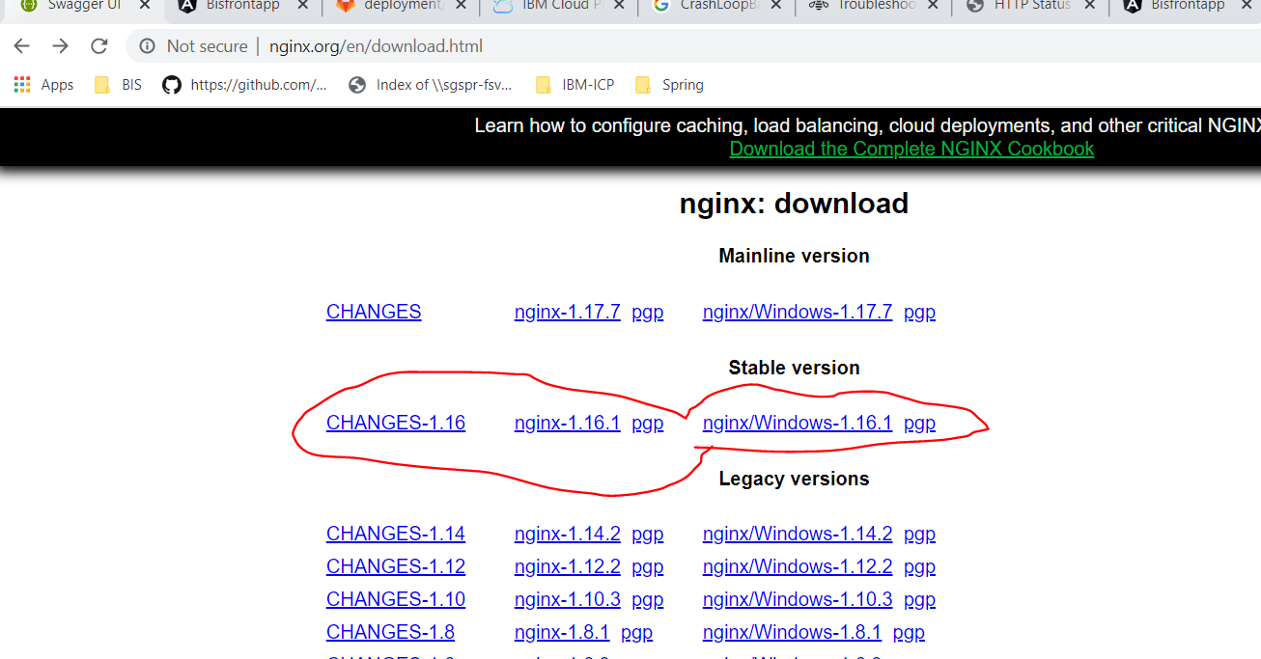

DockerFile for Angular frontend

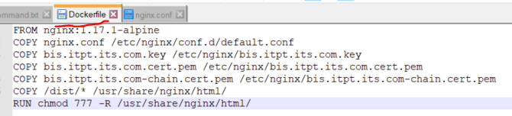

nginx.conf – for angular configuration

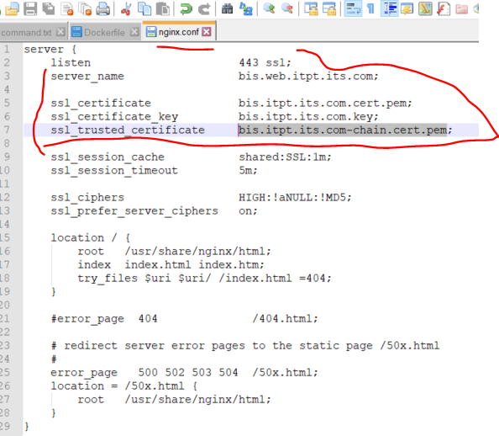

Frontend Folder Structure

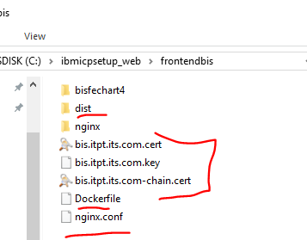

COS Folder Location in GitLab

cos/cos-coms.default-library/deployment

cos/cos-coms.default-library/src/main/resources - application.properties File

# Add DNS (Domain Name Server)

**Two ways**

1. **C:\Windows\System32\drivers\etc\hosts. File (or)**
2. **TCP/IP Properties**

**DNS Name -** 10.180.11.140 bis.itpt.its.com

**DNS Name -** 10.180.11.140 web.bis.itpt.its.com



(Or)

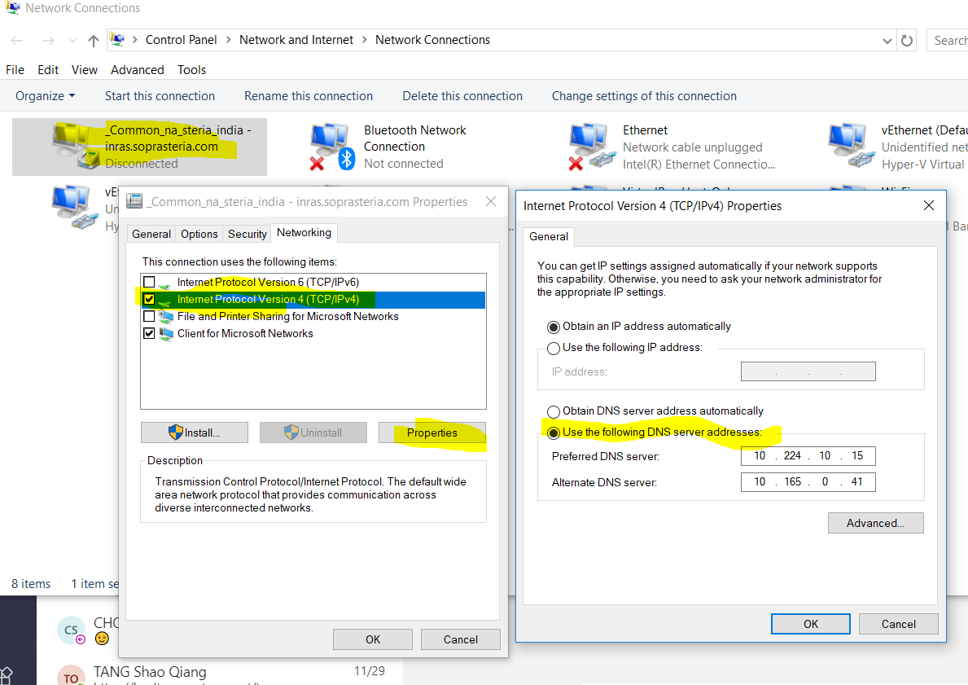

DNS Server        : 10.180.11.82

Alternative DNS Server : 10.180.16.14

# Certificate Creation to create own domain

To get the unique URL

**www.bis.itpt.its.com**

Create a testing.cnf file

|  |  |
| --- | --- |
| [req]  distinguished_name = req_distinguished_name  req_extensions = v3_req  prompt = no  [req_distinguished_name]  C = SG  ST = SG  L = Singapore  O = LTA ITS  OU = i-transport 2.0  CN = bis.itpt.its.com  [v3_req]  keyUsage = keyEncipherment, dataEncipherment  extendedKeyUsage = serverAuth  subjectAltName = @alt_names  [alt_names]  DNS.1 = bis.itpt.its.com  DNS.2 = www.bis.itpt.its.com  DNS.3 = *.bis.itpt.its.com |  |

**Command to run in linux**

openssl req -out bis.itpt.its.com.csr -newkey rsa:2048 -nodes -keyout **bis.itpt.its.com.key** -config **testing.cnf**

**After execute the above command** you can get .csr and .key files

|  |  |
| --- | --- |
| bis.itpt.its.com.csr  bis.itpt.its.com.key | Folder Location: |

**Send email with .csr file to receive .pem file**

**Receive**

|  |  |
| --- | --- |
| bis.itpt.its.com.cert.pem  bis.itpt.its.com-chain.cert.pem | Folder Location: |

# [**How to add certificate chain to keystore?**](https://stackoverflow.com/questions/16062072/how-to-add-certificate-chain-to-keystore)

Open cmd window goto your cert folder (C:\ibmicpclient\cert\Re_BIS_Certificate>)

|  |
| --- |
| keytool -import -trustcacerts -file bis.itpt.its.com-chain.cert.pem -keystore bis.itpt.its.com.p12 -storepass biscertpass -alias bis.itpt.its.com |

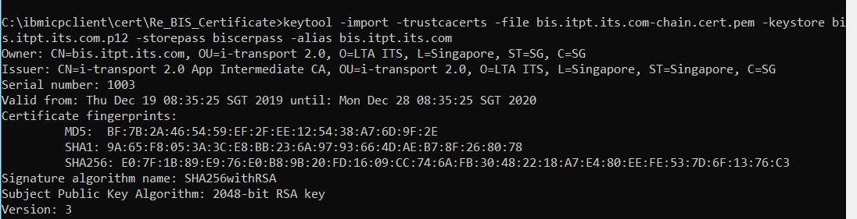

**The bis.itpt.its.com Personal Information Exchange** type file is generated

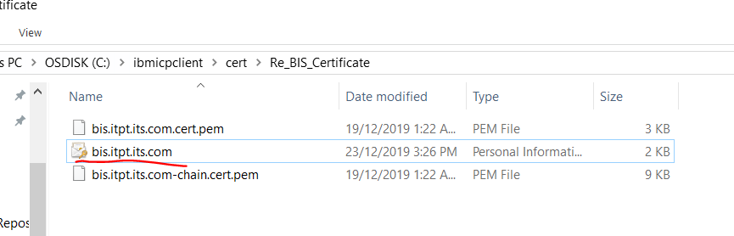

### Enable HTTPS in Spring Boot 2

Add Cert to application.yml file

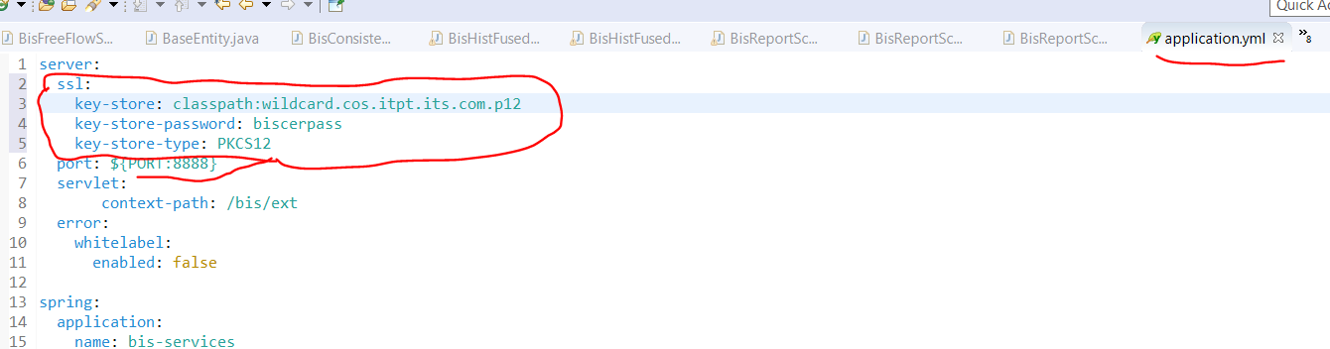

# Docker/kubectl/helm Commands

ICP Login: https://10.180.11.140:8443

itpt2user

P@55w0rd

docker login 10.180.11.140:8500

docker build -t <image name: 10.180.11.140:8500/default/default-library>:<tag : 0.0.1> -f deployment/Dockerfile .

docker push <image name: 10.180.11.140:8500/default/default-library>

docker run -p 8080:9079 -d 10.180.11.140:8500/default/cms-default-library:0.0.1

cloudctl login -a https://10.180.11.140:8443 -u itpt2user -p P@55w0rd -n default

helm init -c

helm version --tls

helm install --name=testing ./testing --tls

helm del --purge testing --tls

List resources

kubectl get <pods/deployments/ingress/service etc..> <--all-namespaces / -n default>

# Linux OS

Goto – Microsoft Store

Search – ubuntu

Login into Microsoft account and Download

window's environment choose

choose a check box - windows for linux

linux

Uname : admin12 / Password: admin12

sudo apt update

sudo apt install openjdk-8-jdk-headless

# Docker General Comments

**PS C:\> docker --version**

Docker version 19.03.5, build 633a0ea

**PS C:\> docker --help**

Usage: docker [OPTIONS] COMMAND

A self-sufficient runtime for containers

Options:

--config string Location of client config files (default

"C:\\Users\\mdevadoss\\.docker")

Management Commands:

builder Manage builds

config Manage Docker configs

**container Manage containers**

context Manage contexts

**image Manage images**

**PS C:\> docker run hello-world**

Unable to find image 'hello-world:latest' locally

latest: Pulling from library/hello-world

1b930d010525: Pull complete

Digest: sha256:4fe721ccc2e8dc7362278a29dc660d833570ec2682f4e4194f4ee23e415e1064

Status: Downloaded newer image for hello-world:latest

Hello from Docker!

This message shows that your installation appears to be working correctly.

**PS C:\> docker image ls**

REPOSITORY TAG IMAGE ID CREATED SIZE

hello-world latest fce289e99eb9 11 months ago 1.84kB

**PS C:\> docker container ls**

CONTAINER ID IMAGE COMMAND CREATED STATUS PORTS NAMES

PS C:\>

**PS C:\> docker container ls --all**

CONTAINER ID IMAGE COMMAND CREATED STATUS PORTS NAMES

ae5d198ed3e9 hello-world "/hello" 8 minutes ago Exited (0) 8 minutes ago upbeat_wilbur

10917366aaad hello-world "/hello" 12 minutes ago Exited (0) 12 minutes ago practical_rosalind

C:\Users\mdevadoss>**docker pull openjdk:8-jdk-alpine**

8-jdk-alpine: Pulling from library/openjdk

e7c96db7181b: Pull complete

f910a506b6cb: Pull complete

c2274a1a0e27: Pull complete

Digest: sha256:94792824df2df33402f201713f932b58cb9de94a0cd524164a0f2283343547b3

Status: Downloaded newer image for openjdk:8-jdk-alpine

docker.io/library/openjdk:8-jdk-alpine

# Testing Environment Setup (Standard way)

Sets to configure application in testing environment

Frontend Testing Environment :

Install Software - angular 7, node.js

1. Install node.js
2. Npm

1. Pull source code from Hitlab

2. Then build the code from the main directory

Command : "**ng build --prod**"

- after build it generate “dist” folder

3. Create new folder in Testing environment

Command: **npm install -g angular-http-server**

4. copy (dist) folder to your new folder

5. Goto the new folder

cd dist/OWA-frontend

**To run the app**

Command: **angular-http-server**

**How to setup**

**Tableau**

**Elixir report**

### **Docker – Elixir Installation**

If you are familiar with Docker you can use the official Docker image to get started quickly with Elixir.

* Enter interactive mode
  + Run: docker run -it --rm elixir
* Enter bash within container with installed elixir
  + Run: docker run -it --rm elixir bash

Those distributions will likely install Erlang automatically for you too. In case they don’t, check the [Installing Erlang](https://elixir-lang.org/install.html#installing-erlang) section below.

**Certificate**

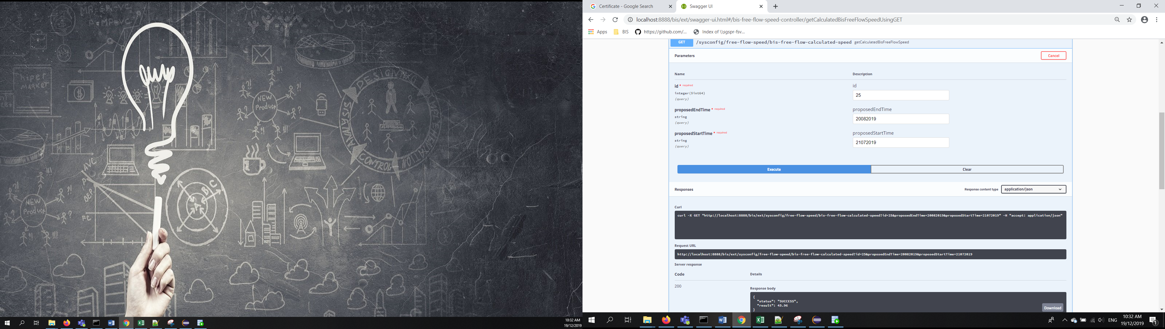

# Configure wired TCP/IP Properties of my computer

From Danbi

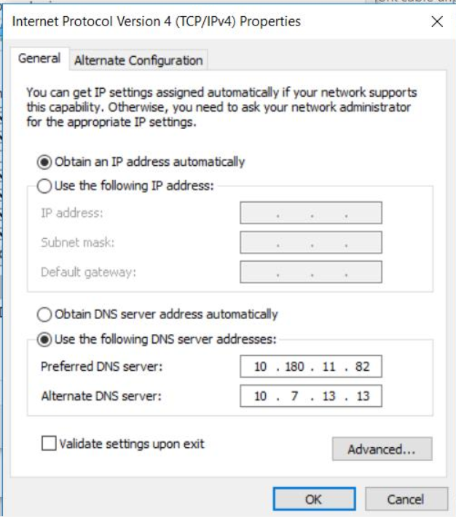

**Local computer setup**

**You can set TCP/IP properties wifi adapter or network adapter**

1. **From the network adapter**

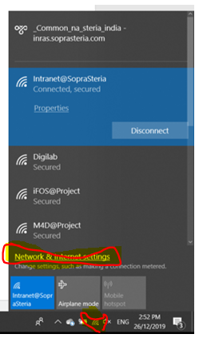

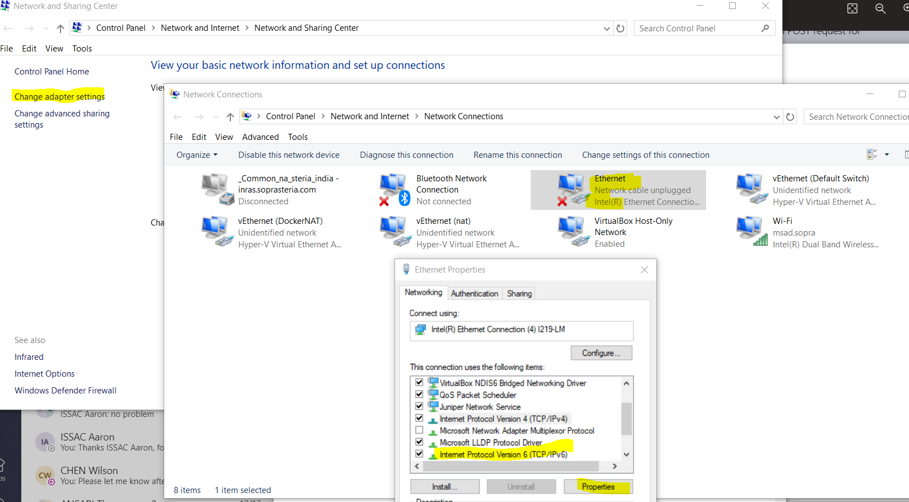

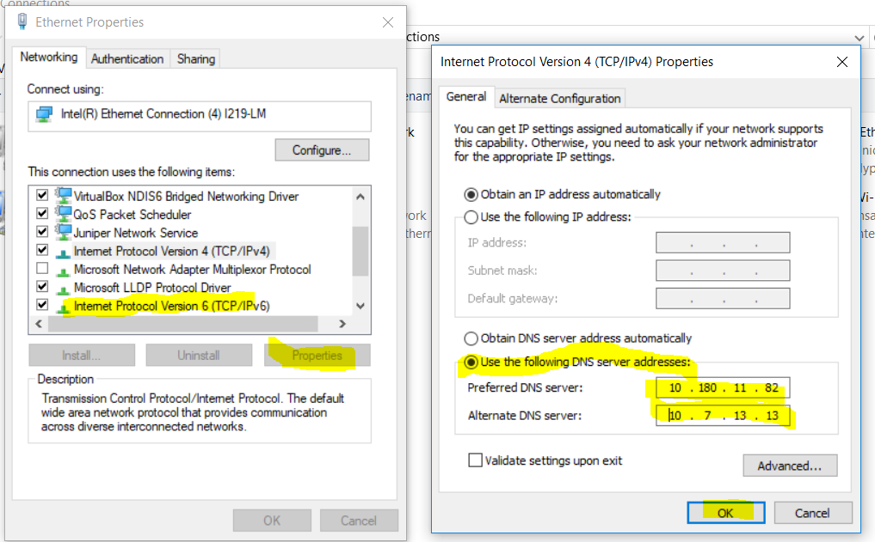

**OR**

1. **The Changes from the Wifi**

**My computer**

**Preferred DNS Server : 10.224.10.15**

**Alternate DNS Server : 10.165.0.41**



# Install Root certificated in Java

Cmd

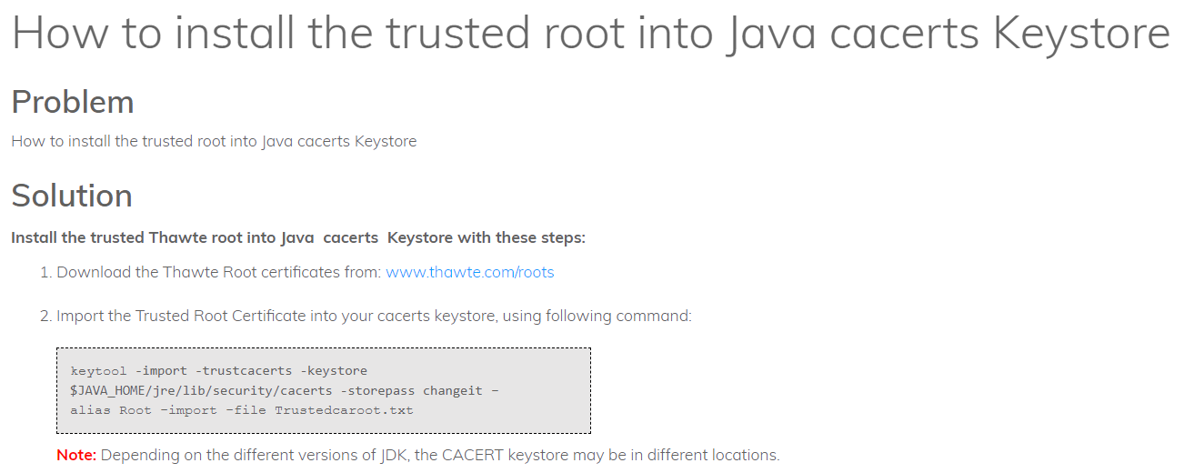

|  |
| --- |
| **Command**  keytool -import -trustcacerts -keystore $JAVA_HOME/jre/lib/security/cacerts -storepass changeit -alias Root -import -file wildcard.cos.itpt.its.com-chain.cert.pem   1. Download the cert 2. Goto that certificate location in CMD 3. Give certificate name with extensions 4. Execute the command |

# SSL Certificate (Secure Sockets Layer)

## Creation using keytool command from JDK

BIS Application

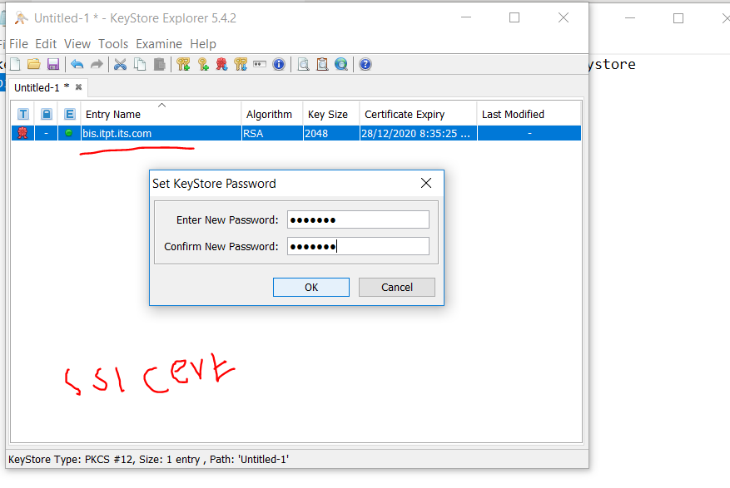

My own example

In jdk there is a command **keytool** to create secured website

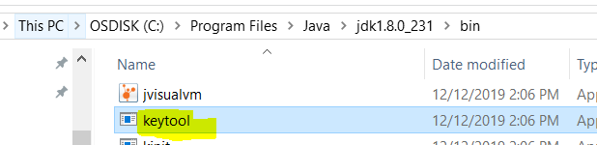

1. Create a new folder
2. Goto command prompt and run keytool command

|  |
| --- |
| * keytool -genkey -alias selfsigned -storetype PKCS12 -keyalg RSA -keysize 2048 -keystore mykeystore.jks -validity 360 |

* -keystore – give certificate name
* -keyalg – algorithm
* -storetype – PKCS12 – standard
* -alias – any name
* Password : pass123

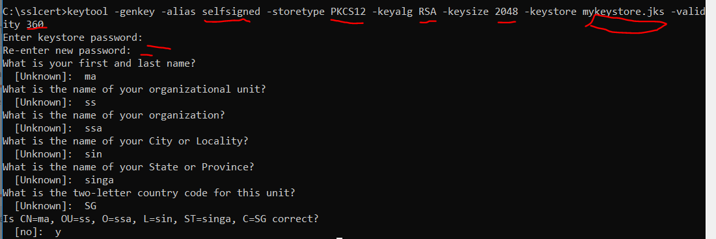

1. New JSK fil is created and stored in mykeystore

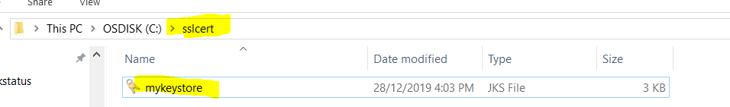

1. Copy mykeystore.JKS file into – springboot resource folder

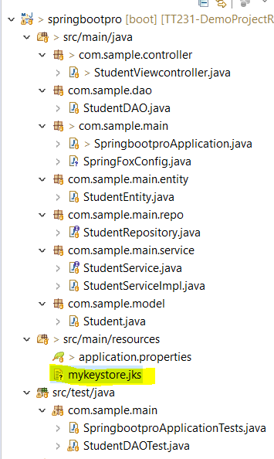

1. Add the following line in application.properties file

|  |
| --- |
| server.ssl.key-store=classpath:mykeystore.jks  server.ssl.key-store-password=pass123  server.ssl.key-password=pass123 |

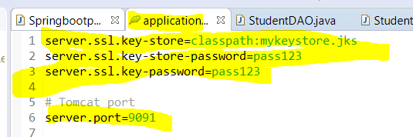

1. Check from tomcat server



1. Postman Changes for SSL Certificate
   * + File – setting – SSL Certificate Verification ON/OFF

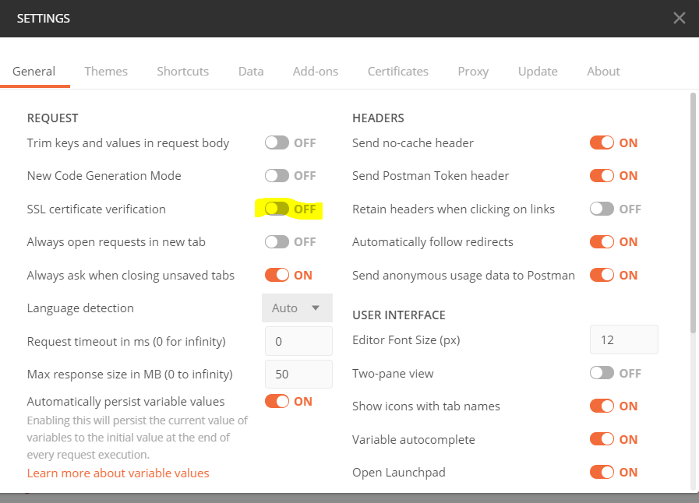

1. In the Browser

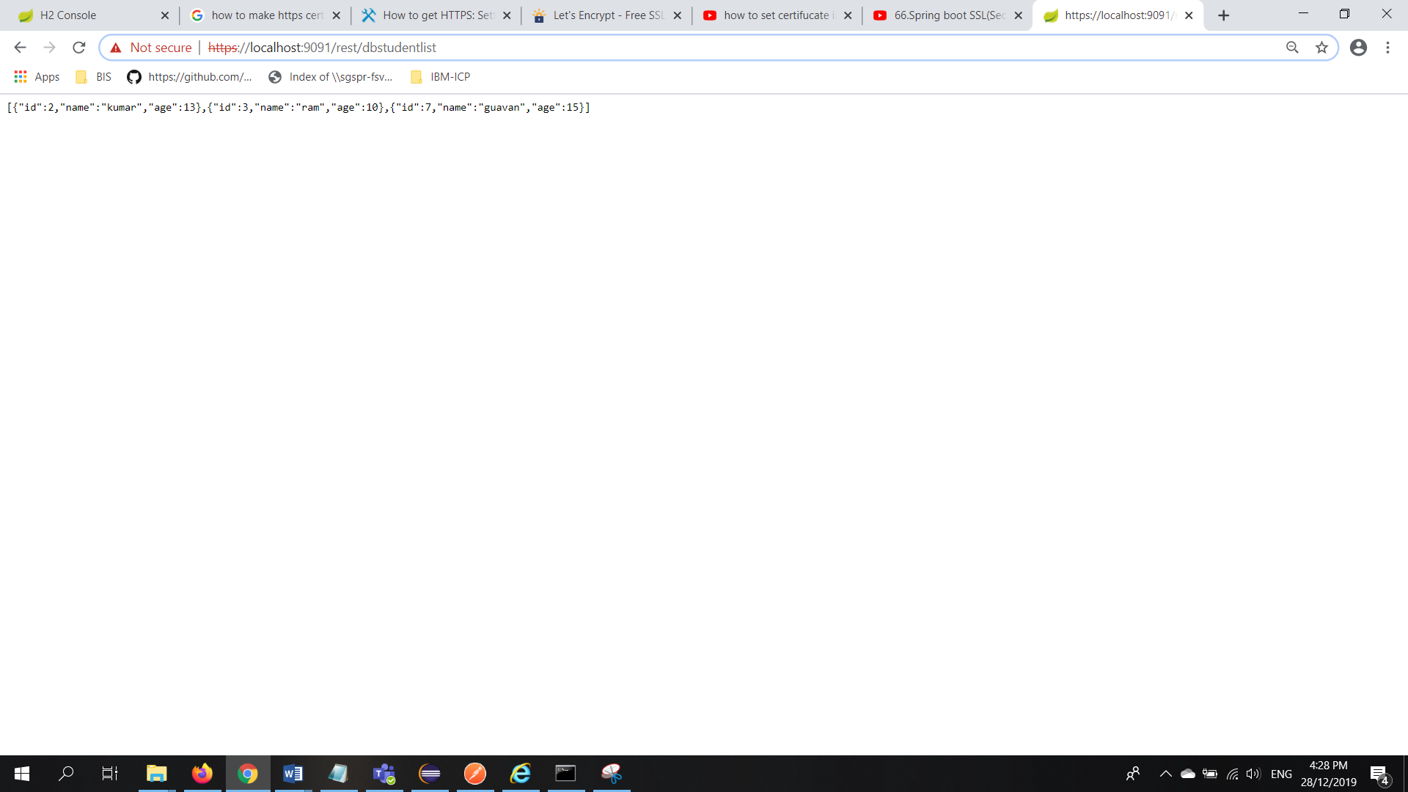

## To open the Certificate using KeyStore explorer

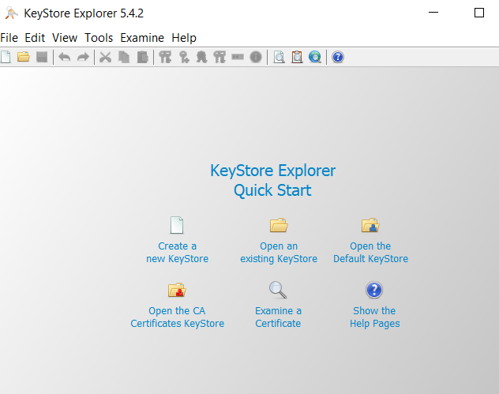

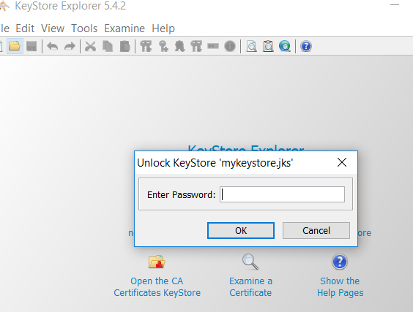

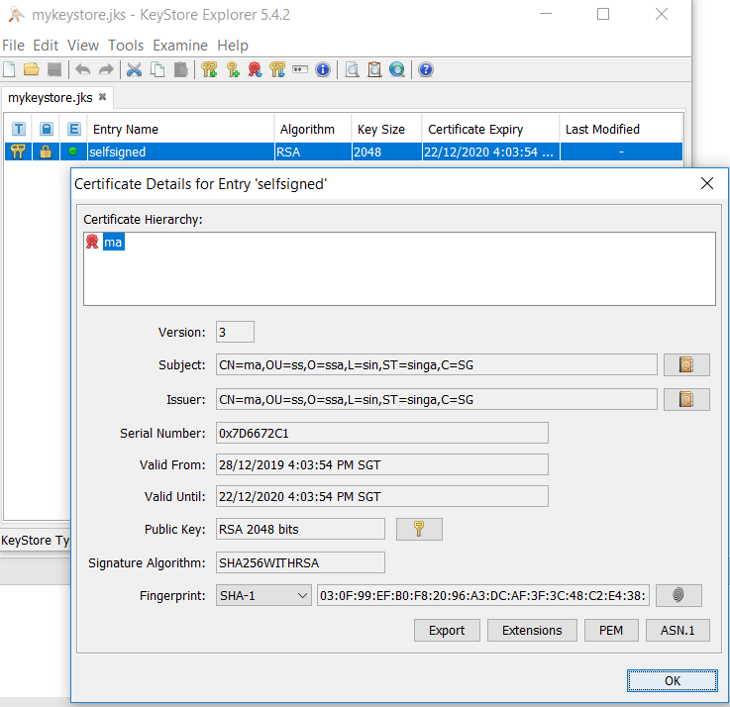

# Kubernetes Tutorial

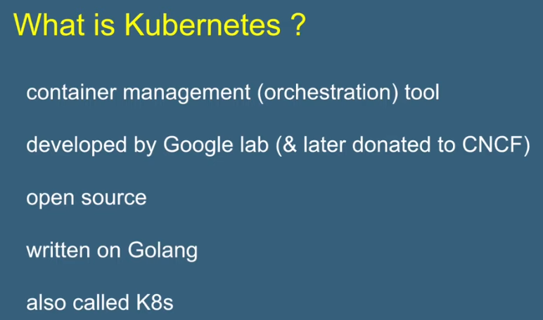

Cloud Native Computing Foundation

Orchestration Management Tool

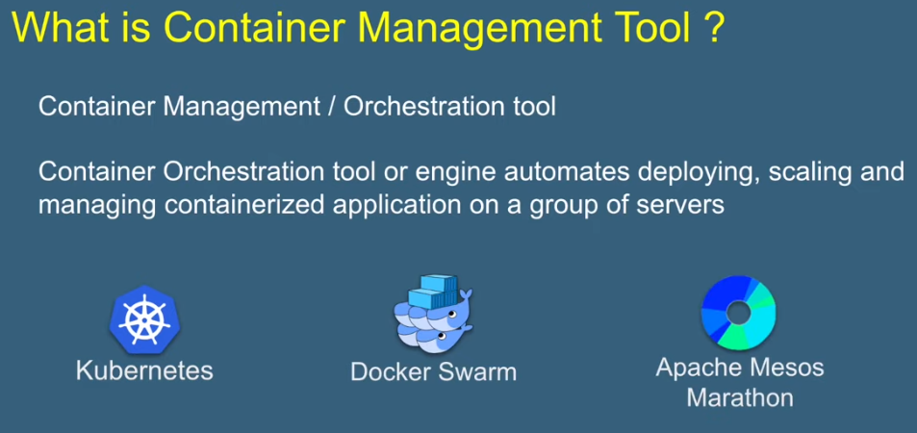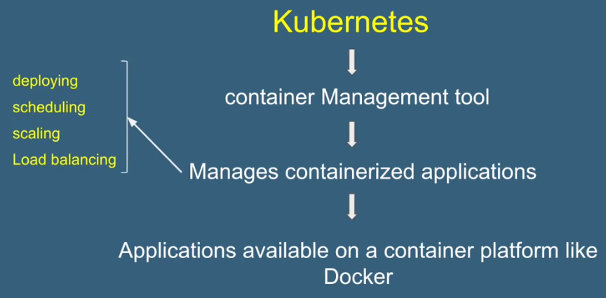

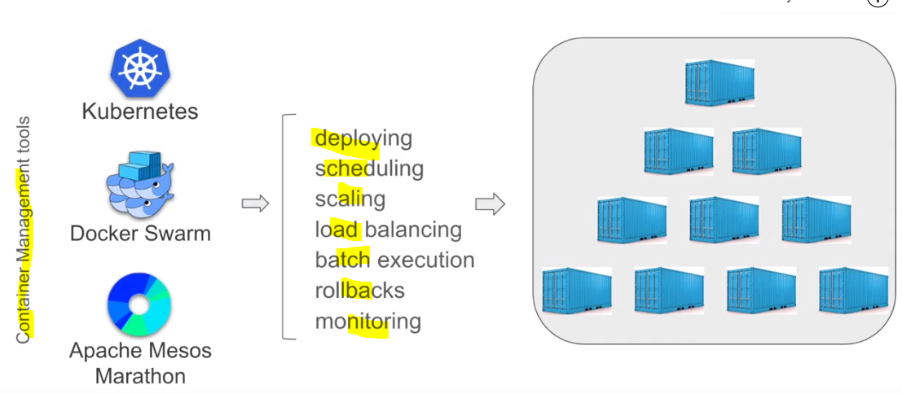

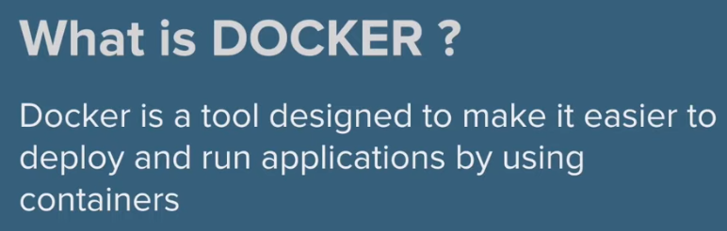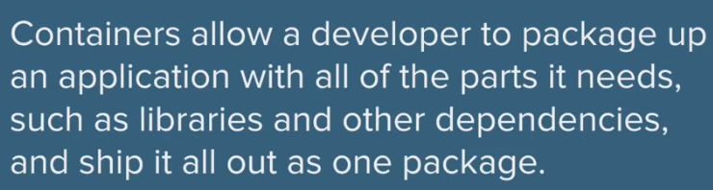

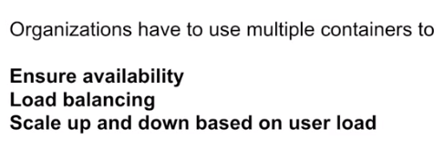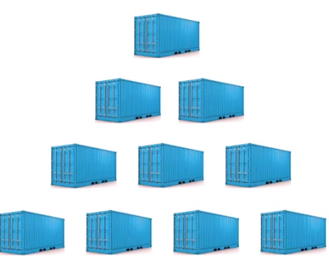

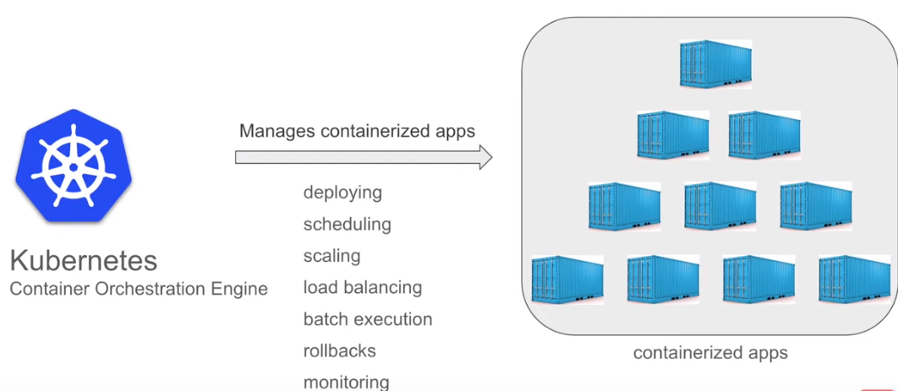

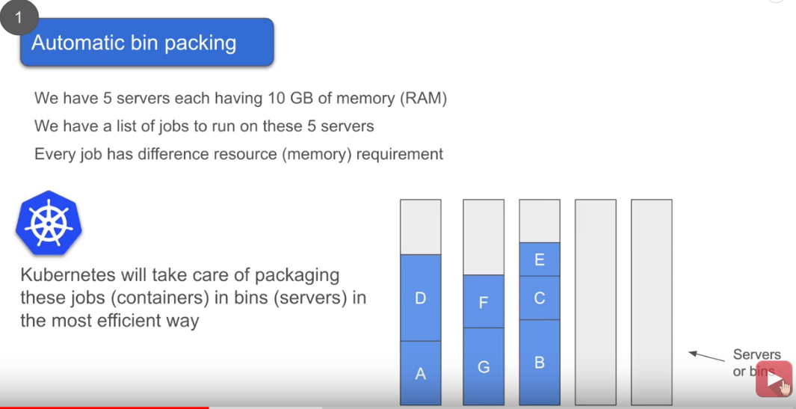

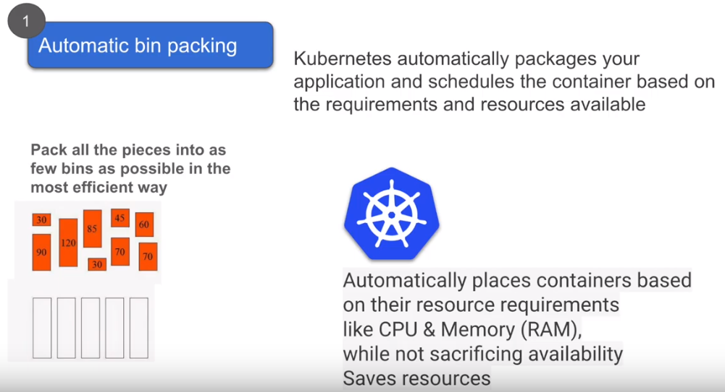

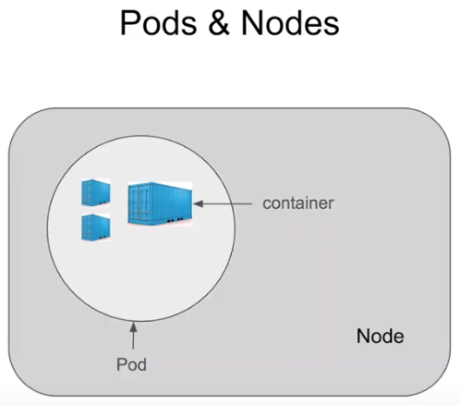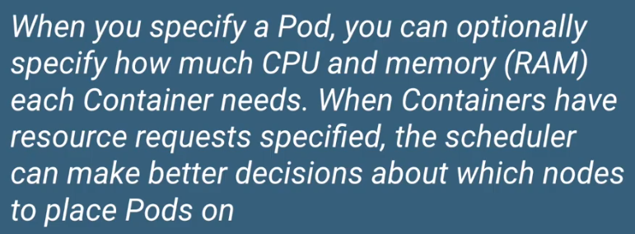

Pods has Multiple containers

Node has Multiple Pods

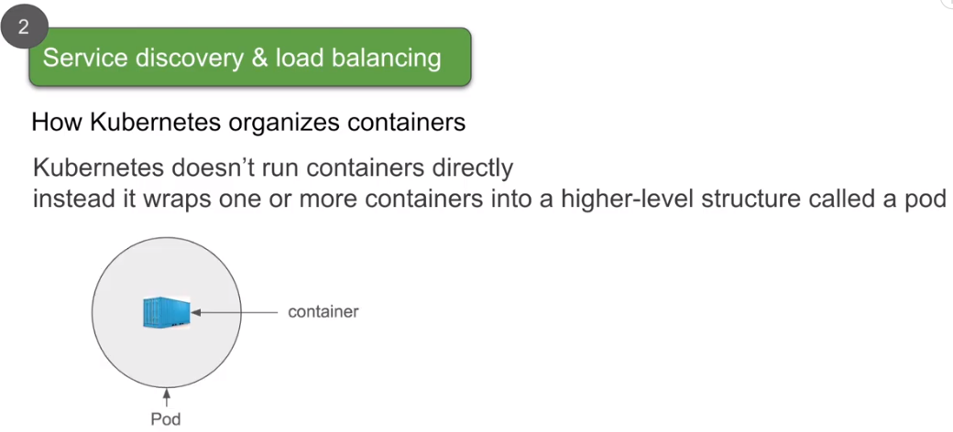

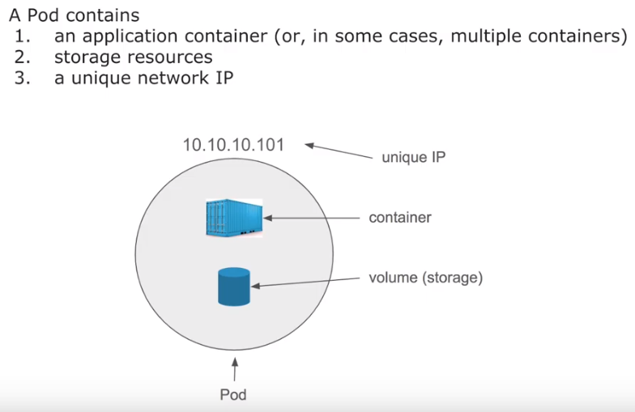

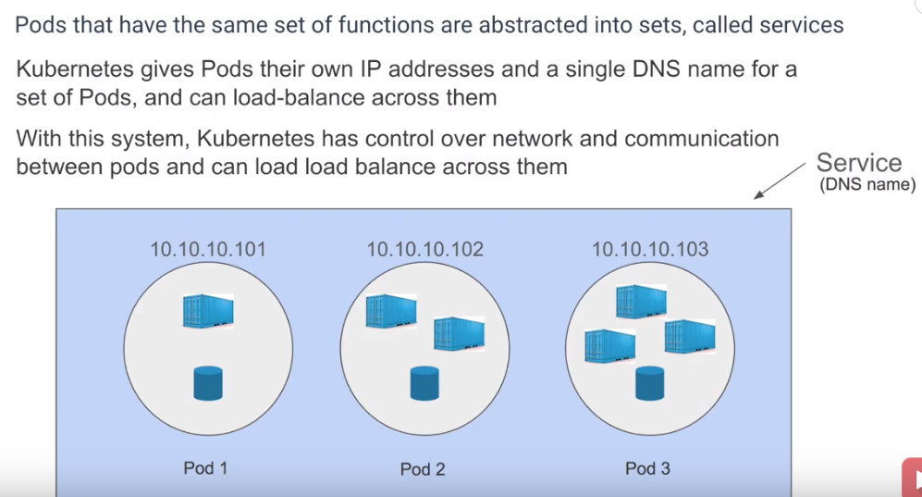

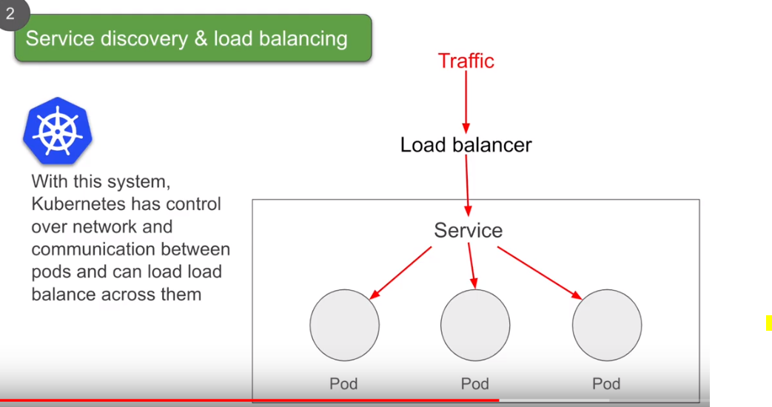

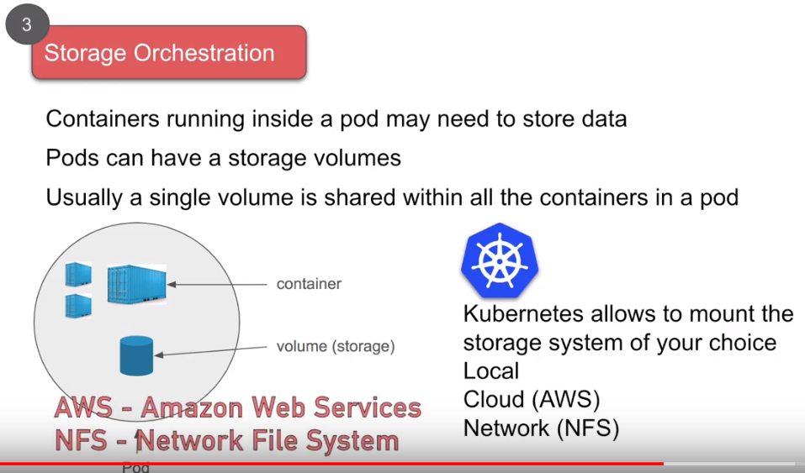

Pod

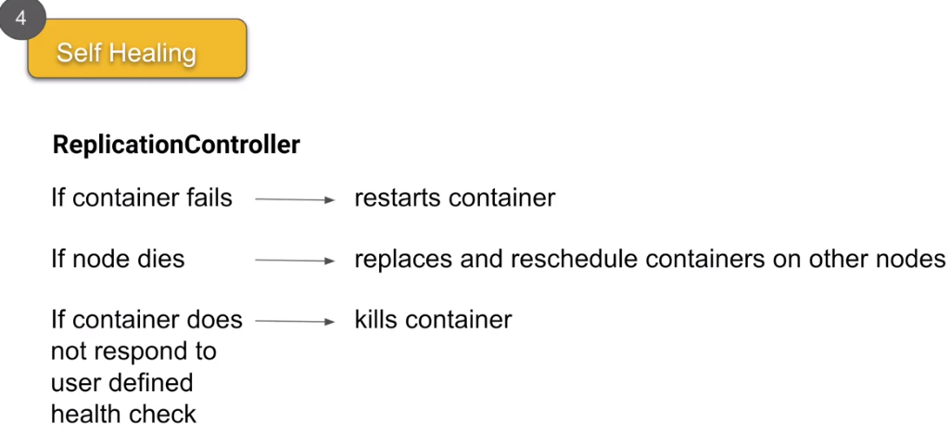

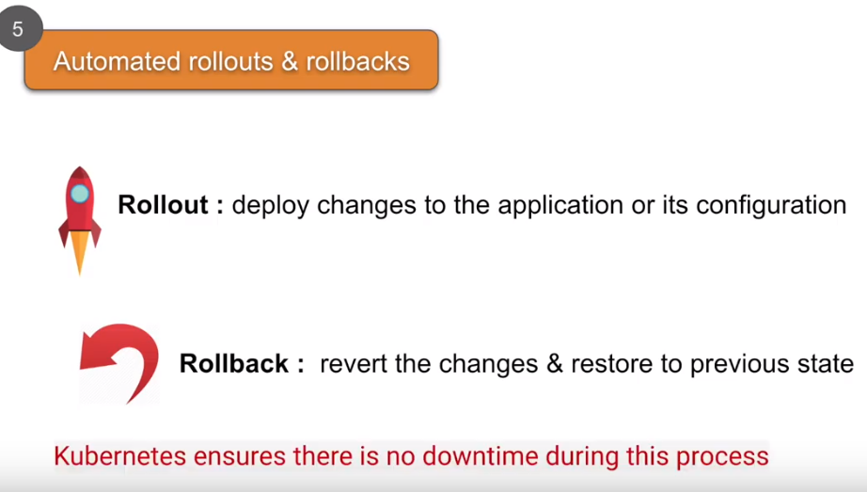

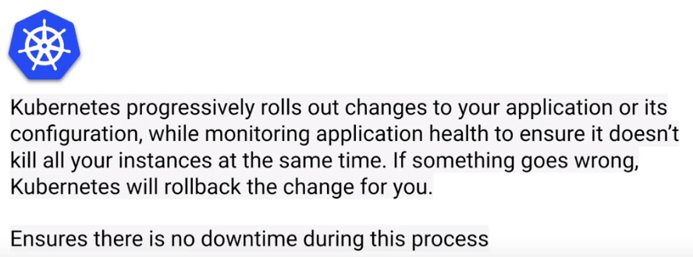

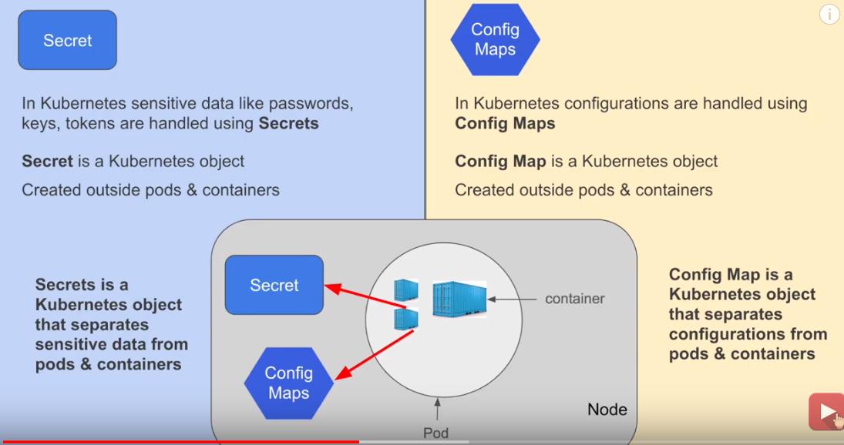

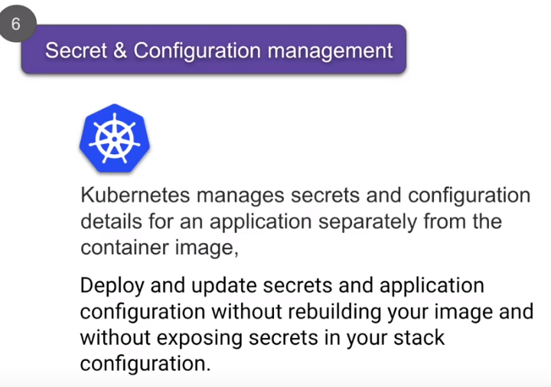

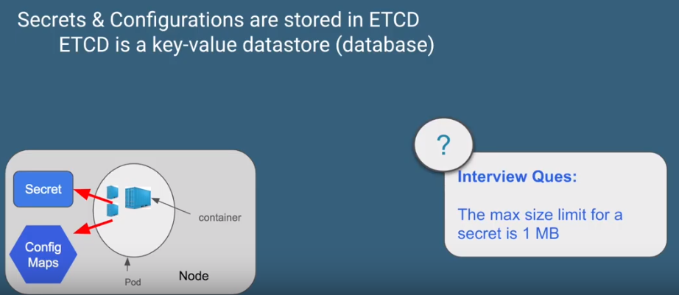

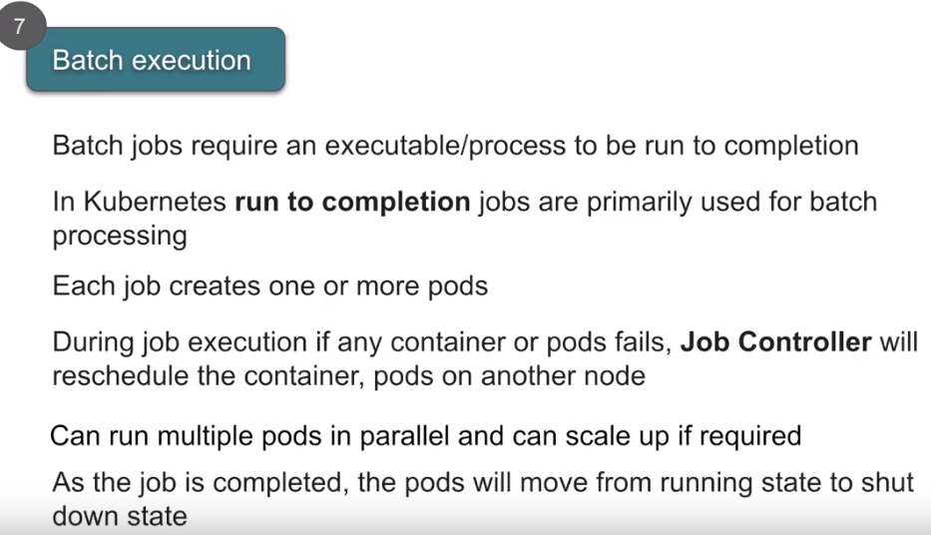

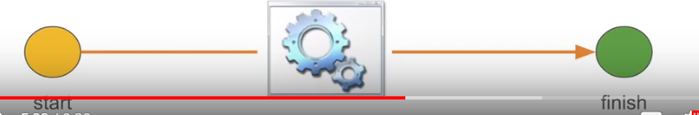

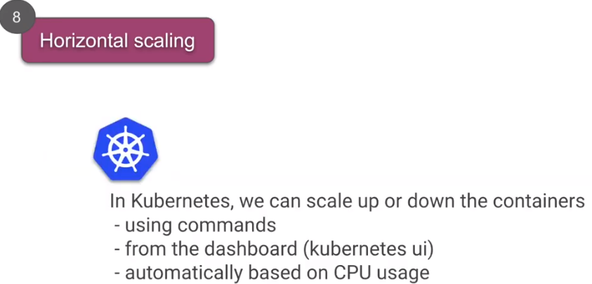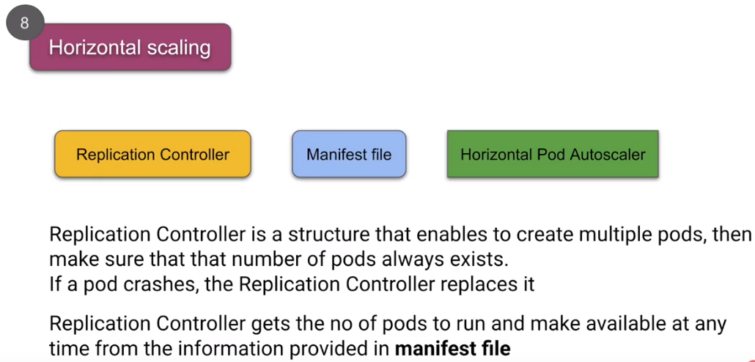

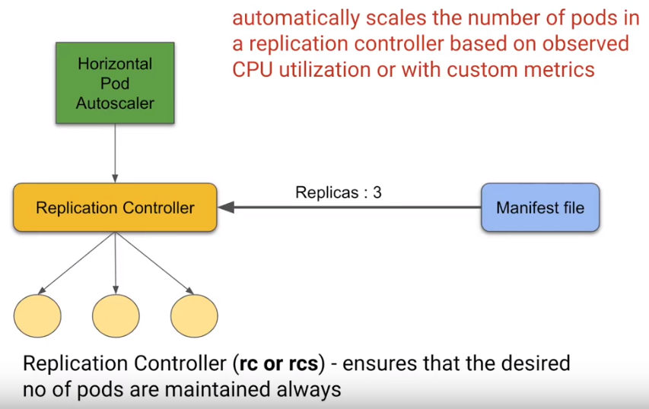

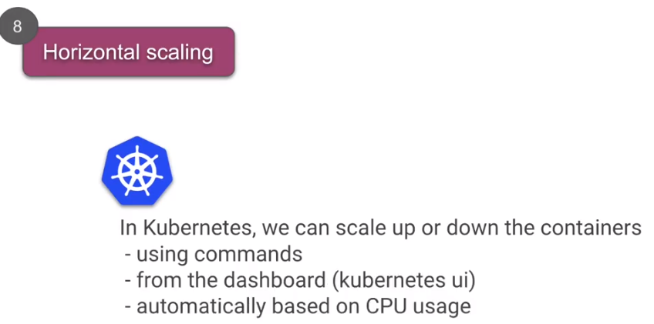

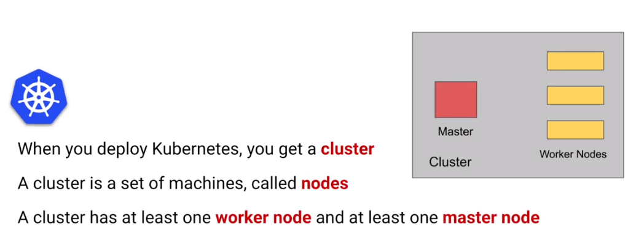

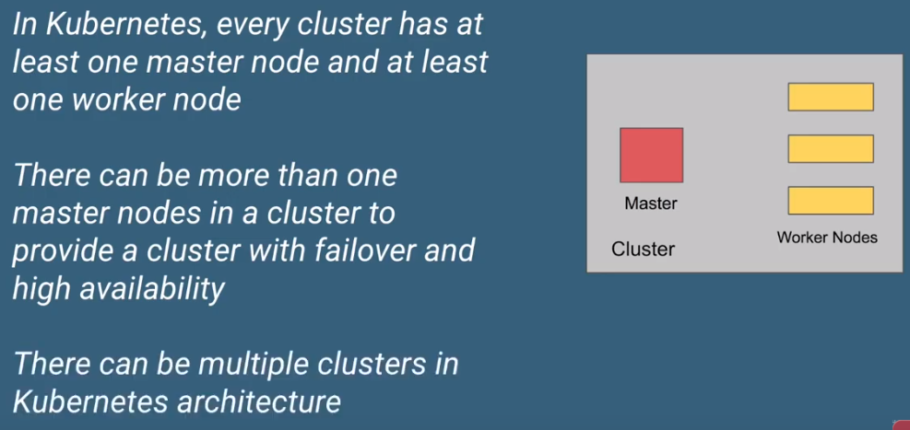

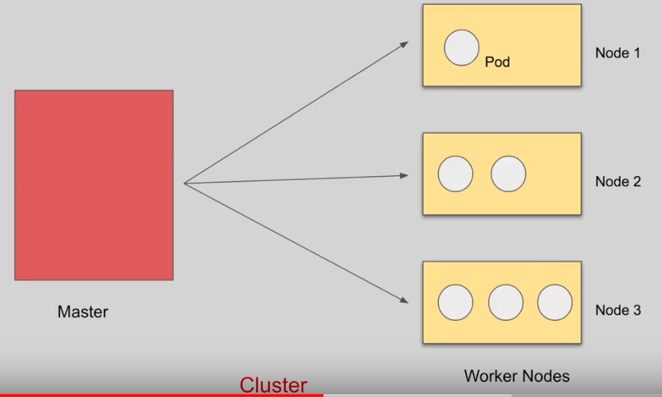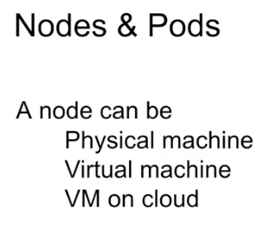

# Kubernetes working notes and facing issues

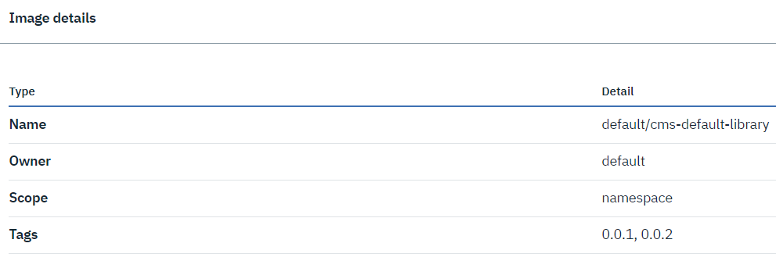

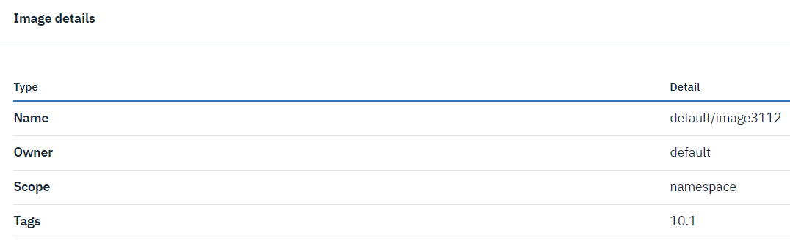

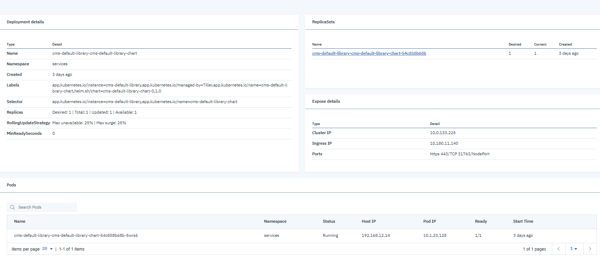

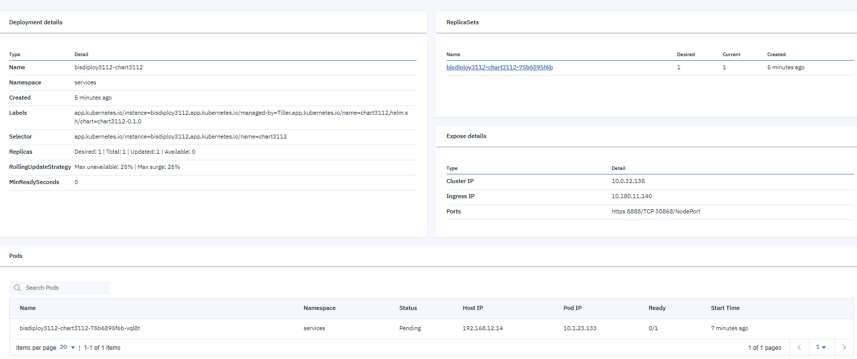

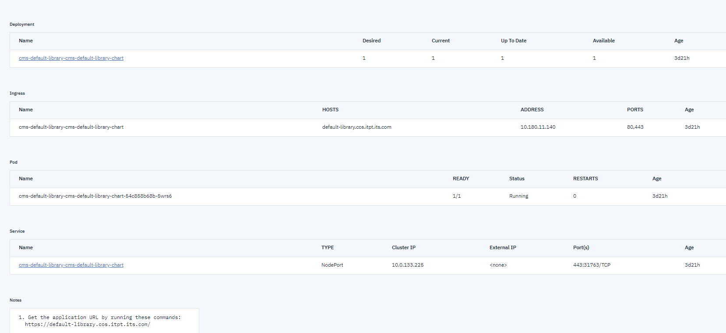

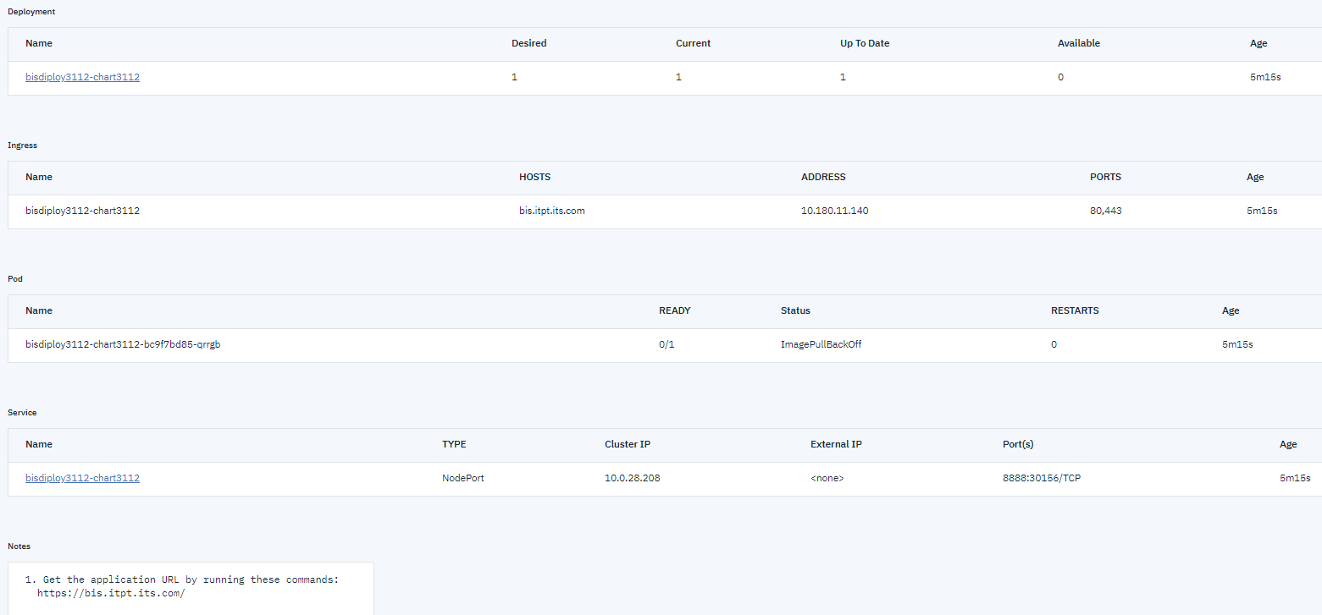

kubectl edit configmap kube-dns -n kube-system